C4 Container diagram
The C4 Container diagram below shows the major containers that make up the SecureNet Platform (services, applications and the data store), together with 2 external systems and the Homeowner actor. Each container is an independent deployable unit. Containers communicate over HTTPS/REST, or MQTT as labelled on the arrows
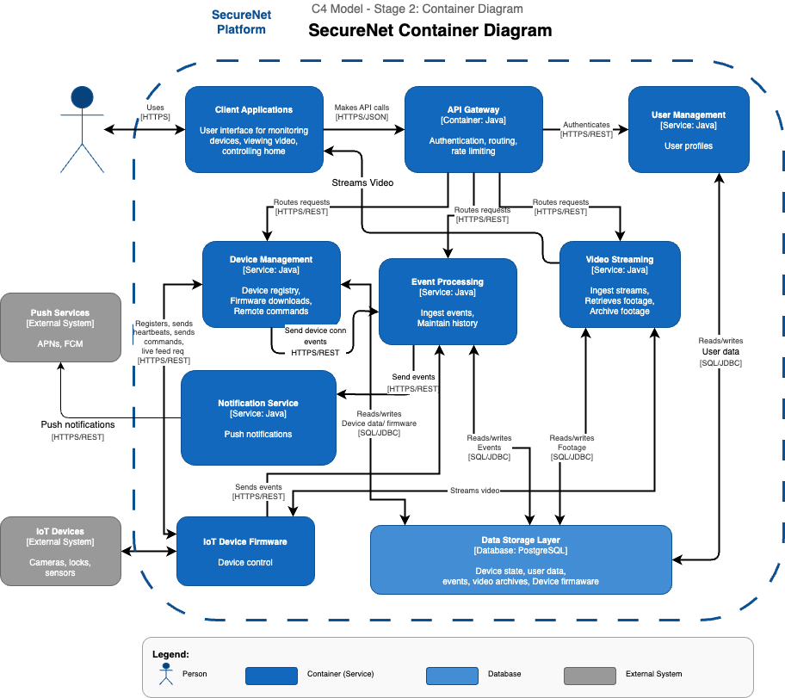
C4 Container Diagram

Main Components of the System
The System is composed of nine containers arranged in three logical tiers:
- Client Tier: Client Application
- Platform Tier: API Gateway, User Management Service, Device Management Service, Event Processing Service, video Streaming Service, Notification Service.
- Data & Device Tier: Data Storage Layer (PostgreSQL), IoT Device Firmware (on device).

Two external systems integrate with the platform:
- Push Services (APN’s/FCM) - deliver push notifications to iOS and android devices.
- IoT Devices (camera, smart locks, motion sensors - the physical hardware running SecureNet firmware.

2.1) Client Applications
The primary interface between the homeowner and the secureNet platform. It communicates with the API Gateway exclusively over HTTPS/JSON.

Responsibilities:
- Display live device status,security event timeline and system health dashboard.
- Render live camera feeds and search through archived footage.
- Accept homeowner commands (lock/unlock doors, open a stream), and forward them to the API Gateway.
- Register the device’s APNs or FCM push token with the Notification Service on first launch.
- Display cached device state with a warning indicator when the cloud is unreachable.
Key API methods (ClientApplicationService):
- login(email, rawPassword) - Authenticate homeowner, store bearer token for all subsequent requests
- logout() - Revoke session token, clear cached credentials, return to login screen
- registerPushToken(pushToken) - Register OS-issued APNs/FCM token with Notification Service on first launch
- loadDashboard() - Fetch device list from API Gateway, fall back to cached state if cloud unreachable
- startDeviceOnboarding(qrPayloadOrDeviceId, deviceType) - Initiate QR scan flow, send registration request to API Gateway
- sendLockCommand(deviceId) - Send lock command via API Gateway
- sendUnlockCommand(deviceId) - Send unlock command via API Gateway
- loadEventTimeline(deviceId, from, to, maxEvents) - Fetch and display event history for a device
- startLiveStream(deviceId) - Check cloud availability, request stream via API Gateway, initialize player
- stopLiveStream(streamSessionId) - Stop active stream, release player
- openVideoPlayback(deviceId, from, to) - Fetch signed clip URLs, initialize playback player
- onBandwidthChange(sessionId, bandwidthKbps) - Handle adaptive quality change, notify homeowner if degraded or restored
- onCloudConnectionLost() - Switch to cached state, show warning, disable remote controls
- onCloudConnectionRestored() - Re-fetch live state, clear warnings, re-enable controls
Key interactions:
- API Gateway: All API calls - HTTPS/JSON on port 443 (HTTPS/TLS)
- Video Streaming Service: Receives live and playback video chunks directly (bypasses gateway for efficiency).
- Homeowner: Presents UI

2.2) API Gateway
The single entry point for all HTTPS/JSON requests originating from the Client Application. No backend service is reachable without passing through the gateway.

Responsibilities:
- Authenticate every inbound request by calling UserManagementService.validateToken() before routing.
- Route validated requests to the appropriate downstream service based on the API path
- Perform load balancing; detect unhealthy service instances and route around them, logging each incident

Key API methods (APIGatewayService):
- authenticateRequest(rawBearerToken)- Validate bearer token; return AuthToken or throw AuthenticationException.
- routeRequest(token, serviceName, endPoint, payload)- Forward authenticated request to named service or throw ServiceUnavaliableException if no healthy instance.

Key Interactions:
- User Management Service: Validates every token, communicates over HTTPS/REST
- Device Management Service: Forwards device commands (HTTPS/REST)
- Video Streaming Service: Forward playback / clip list requests (HTTPS/REST)
- Event Processing Service: Forwards event history queries (HTTPS/REST)

2.3) User Management Service
The sole authority for homeowner identity. Owns account creation, authentication, and the full lifecycle of bearer tokens.

Responsibilities:
- Register new homeowner accounts (hashes passwords before persisting).
- Issue short lived signed bearer (JWTs) after successful login.
- Validate tokens on every inbound request (path uses signature and expiry check to avoid a database round trip on each call).
- Maintain a revocation list for logged out or password changed tokens.

Key API methods:
- registerUser(email, displayName, password) - Create account, hash password, return user
- login(email, password)- Verify credentials, issue AuthToken
- validateToken(rawBearerToken) - verify JWT signature & expiry without db trip, checks revocation list (this is a hot path).
- revokeToken(token)- Add token to revocation list (called on logout)

Key Interactions:
- API Gateway: Called by gateway to validate every request token (HTTPS/REST)
- Data Storage Layer: Read/Write user records and push-token registry (SQL/JDBC)

2.4) Device Management Service
The authoritative registry for all IoT devices. Manages the complete device lifecycle from first QR-code scan through deregistration, including heartbeat monitoring, remote command dispatch, and firmware distribution.

Responsibilities:
- Onboarding: validate QR code payload, create device record, generate MQTT credentials complete device handshake.
- Registry: Execute CRUD operations on device records stored in the Data Storage Layer.
- Heartbeat Monitoring: track last seen timestamp per device, transition status to UNRESPONSIVE when the threshold is exceeded.
- Remote Commands: publish LOCK, UNLOCK, STREAM_START, and FIRMWARE_UPDATE commands to individual devices via MQTT.
- Firmware Distribution: ​​maintain versioned firmware binaries in storage, push update commands to devices on demand or automatically.

Key API methods (DeviceManagementService):
- registerDevice(ownerId, type, qrPayload) - Parse QR code, create device record, return Device in PENDING_REGISTRATION state.
- acceptDeviceRegistration(deviceId, token)- Complete handshake, return DeviceCredentials for MQTT broker.
- recordHeartbeat(deviceId)- Update last-seen, transition OFFLINE/UNRESPONSIVE -> ONLINE
- markDeviceUnresponsive(deviceId)- Called by heartbeat-monitor, triggers alert via Notification Service
- sendLockCommand(deviceId)- Publish LOCK to device MQTT topic, wait for ack, return success/timeout
- sendUnlockCommand(deviceId)- Publish UNLOCK to device MQTT topic…
- sendStreamStartCommand(deviceId, streamTargetUrl)- Requests the device to begin streaming video to the Video Streaming Service.
- pushFirmwareUpdate(deviceId, version)- Publish FIRMWARE_UPDATE command, device fetches firmware from storage

Key Interactions:
- IoT Device Firmware: Receives heartbeats, registration calls (HTTPS/REST/MQTT)
- Event Processing Service: Trigger alerts when device goes unresponsive
- Data Storage Layer: Read/write device records and firmware (SQL/JDBC)

2.5) Event Processing Service
Ingests raw security events from IoT devices, enriches them with platform context, writes them to the event history, and routes alert-worthy events to the Notification Service.

Responsibilities
- Receive raw events (motion detected, door locked/unlocked, connectivity changes, device unresponsive) published by device firmware over HTTPS/REST.
- Enrich raw events: attach owner ID (looked up from device registry) and device display name before persisting.
- Persist enriched SecurityEvent objects to the Data Storage Layer (event history table).
- Evaluate alert criteria and forward qualifying events to the Notification Service.
- Serve event history queries from Client Applications via the API Gateway.

Key API methods (EventProcessingService)
- ingestEvent(deviceId, type, occurredAt, metadata)- Validate, enrich, persist.
- routeAlertIfRequired(event)- Evaluate alert rules;, forwards to NotificationService if criteria are met.
- getEventHistory(deviceId, from, to, maxEvents)- Return time-windowed event list for a specific device.
- getEventsByTypeForOwner(ownerId, type, from, to, max)- Return filtered event feed for homeowner

Key Interactions
- IoT Device Firmware: Receives raw events (HTTPS/REST).
- NotificationService: Forwards alert-worthy events (HTTPS/REST).
- Data Storage Layer: Read/write event history (SQL/JDBC)

2.6) Video Streaming Service
Handles all video data, ingesting live streams from cameras, archiving footage, and delivering playback to Client Applications via short-lived signed URLs. Live video is streamed directly to the client, bypassing the API Gateway to avoid unnecessary latency and bandwidth overhead.

Responsibilities:
- Ingest live streams pushed by camera firmware, buffer chunks for real-time viewing.
- Implement adaptive bitrate streaming, detect client bandwidth (≥2000 Kbps use HD/1080p, 500–1999 Kbps use 480p, <500 Kbps use 240p) and serve the appropriate quality tier per chunk.
- Archive video segments to the Data Storage Layer and create VideoClip metadata records.
- Generate time-limited signed HTTPS URLs for clip playback so raw storage credentials are never exposed to the client.
Key API methods (Video Streaming Service)
- startLiveStream(deviceId, ownerId)- Open ingestion session, return streamSessionId to client.
- getNextChunkUrl(sessionId, bandwidthKbps)- Select quality tier, return signed URL for next chunk.
- selectQualityTier(bandwidthKbps)- Return 'HD', 'SD', or 'LOW' based on bandwidth threshold.
- archiveFootage(deviceId, ownerId, started, bytes)- Persist segment, create VideoClip record
- findClips(deviceId, from, to)- Return clip list for a time window
- generateSignedPlaybackUrl(clipId, validForSeconds)- Issue time limited URL for client-side playback

Key Interactions:
- IoT Device Firmware (Camera): Receives stream
- Client Applications: Delivers video chunks directly (HTTPS)
- Data Storage Layer: Read/write footage (SQL/JDBC)

2.7) Notification Service
Delivers real-time push notifications to homeowners clients. Serves as the sole integration point with Apple Push Notification service (APNs) and Google Firebase Cloud Messaging (FCM).

Responsibilities:
- Maintain a registry of APNs and FCM device tokens, one per homeowner device, stored in the Data Storage Layer.
- On receiving an alert-worthy SecurityEvent from the Event Processing Service, construct a notification payload and dispatch it to every token registered to the event's owner.
- Route each notification through the correct external service (APNs for iOS; FCM for Android/web).
- Deregister tokens that APNs or FCM reports as invalid.

Key API Methods:
- registerPushToken(userId, pushToken, platform)- Store APNs or FCM token for a homeowner device
- deregisterPushToken(pushToken)- Remove a token (logout, OS invalidation)
- sendEventAlert(event)- Format and dispatch notification to all owner tokens
- dispatchViaApns(apnsToken, payload)- Send pre-formatted payload via APNs HTTP/2 API
- dispatchViaFcm(fcmToken, payload)- Send pre-formatted payload via FCM HTTP v1 API

Key Interactions:
- Event Processing Service: Receives alert events (HTTPS/REST).
- Push Services (APNs/FCM): Dispatches notifications to external platforms (HTTPS/REST)
- Data Storage Layer: Read/write push-token registry (SQL/JDBC)

2.8) IoT Device firmware
The software running on SecureNet-compatible IoT hardware (cameras, smart locks, motion sensors)

Responsibilities:
- Connect to WiFi with exponential back-off and register with the Device Management Service using the QR code one time token.
- Open and maintain a persistent TLS/MQTT connection to the SecureNet broker to receive commands.
- Send a heartbeat to the Device Management Service every 30 seconds so the cloud can track device health.
- Detect and publish security events (motion, lock state changes, connectivity changes) to the Event Processing Service over HTTPS/REST.
- Buffer events and video segments to local storage when WiFi is unavailable, sync automatically when connectivity is restored.

Key API methods (IoTDeviceFirmwareService):
- connectToWifi(ssid, password)- Connect with exponential back-off, return true on success
- registerWithCloud(registrationToken)- POST to Device Management Service, store returned DeviceCredentials
- connectToMqttBroker(credentials)- Open persistent MQTT connection; subscribe to command topic
- sendHeartbeat()- POST heartbeat to Device Management Service every 30s
- publishEvent(type, metadata)- POST event to Event Processing Service; buffer locally if offline
- handleCommand(commandType, params)- Process incoming MQTT command (LOCK, UNLOCK, STREAM_START, etc.)
- bufferLocally(dataType, payload)- Write event or video segment to local storage
- syncBufferedData()- Upload all buffered items after WiFi restored, return count delivered

Key Interactions:
- Device Management Service: Sends registration request and heartbeats (HTTPS/REST), receives LOCK, UNLOCK, STREAM_START, and FIRMWARE_UPDATE commands (MQTT)
- Video Streaming Service: Pushes live video stream directly; delivers buffered video segments on reconnect (HTTPS/REST)
- Event Processing Service: Publishes security events (motion, lock state changes, connectivity changes) over HTTPS/REST; buffers locally and syncs on reconnect
- Physical IoT Devices: Receives hardware interrupts from sensors (motion detection, lock state changes), sends actuation commands to hardware (engage/disengage lock motor, start/stop camera capture)

2.9) Data Storage Layer
The single persistence layer shared by all SecureNet platform services. Backed by PostgreSQL, it stores five logically distinct data domains in a single cluster. Each service accesses it directly via SQL/JDBC. No storage queries are routed through the API Gateway.

Data stored
- User data: Homeowner accounts, hashed passwords, push-token registry
- Device state: Device registry, credentials, firmware version, last-seen timestamp, status
- Event History: Time-ordered enriched SecurityEvent records
- Video archives: VideoClip metadata + raw encoded video segment bytes
- Firmware: Versioned firmware for each DeviceType

Key Interactions:
All key interactions between the data layer and other services were explained under each service.

Workflows - How work moves between components
Five BPMN workflow diagrams capture how the SecureNet components collaborate to deliver the platform's key capabilities. Each workflow is represented as a multi-pool BPMN diagram.

3.1) Workflow 1 - Device Onboarding
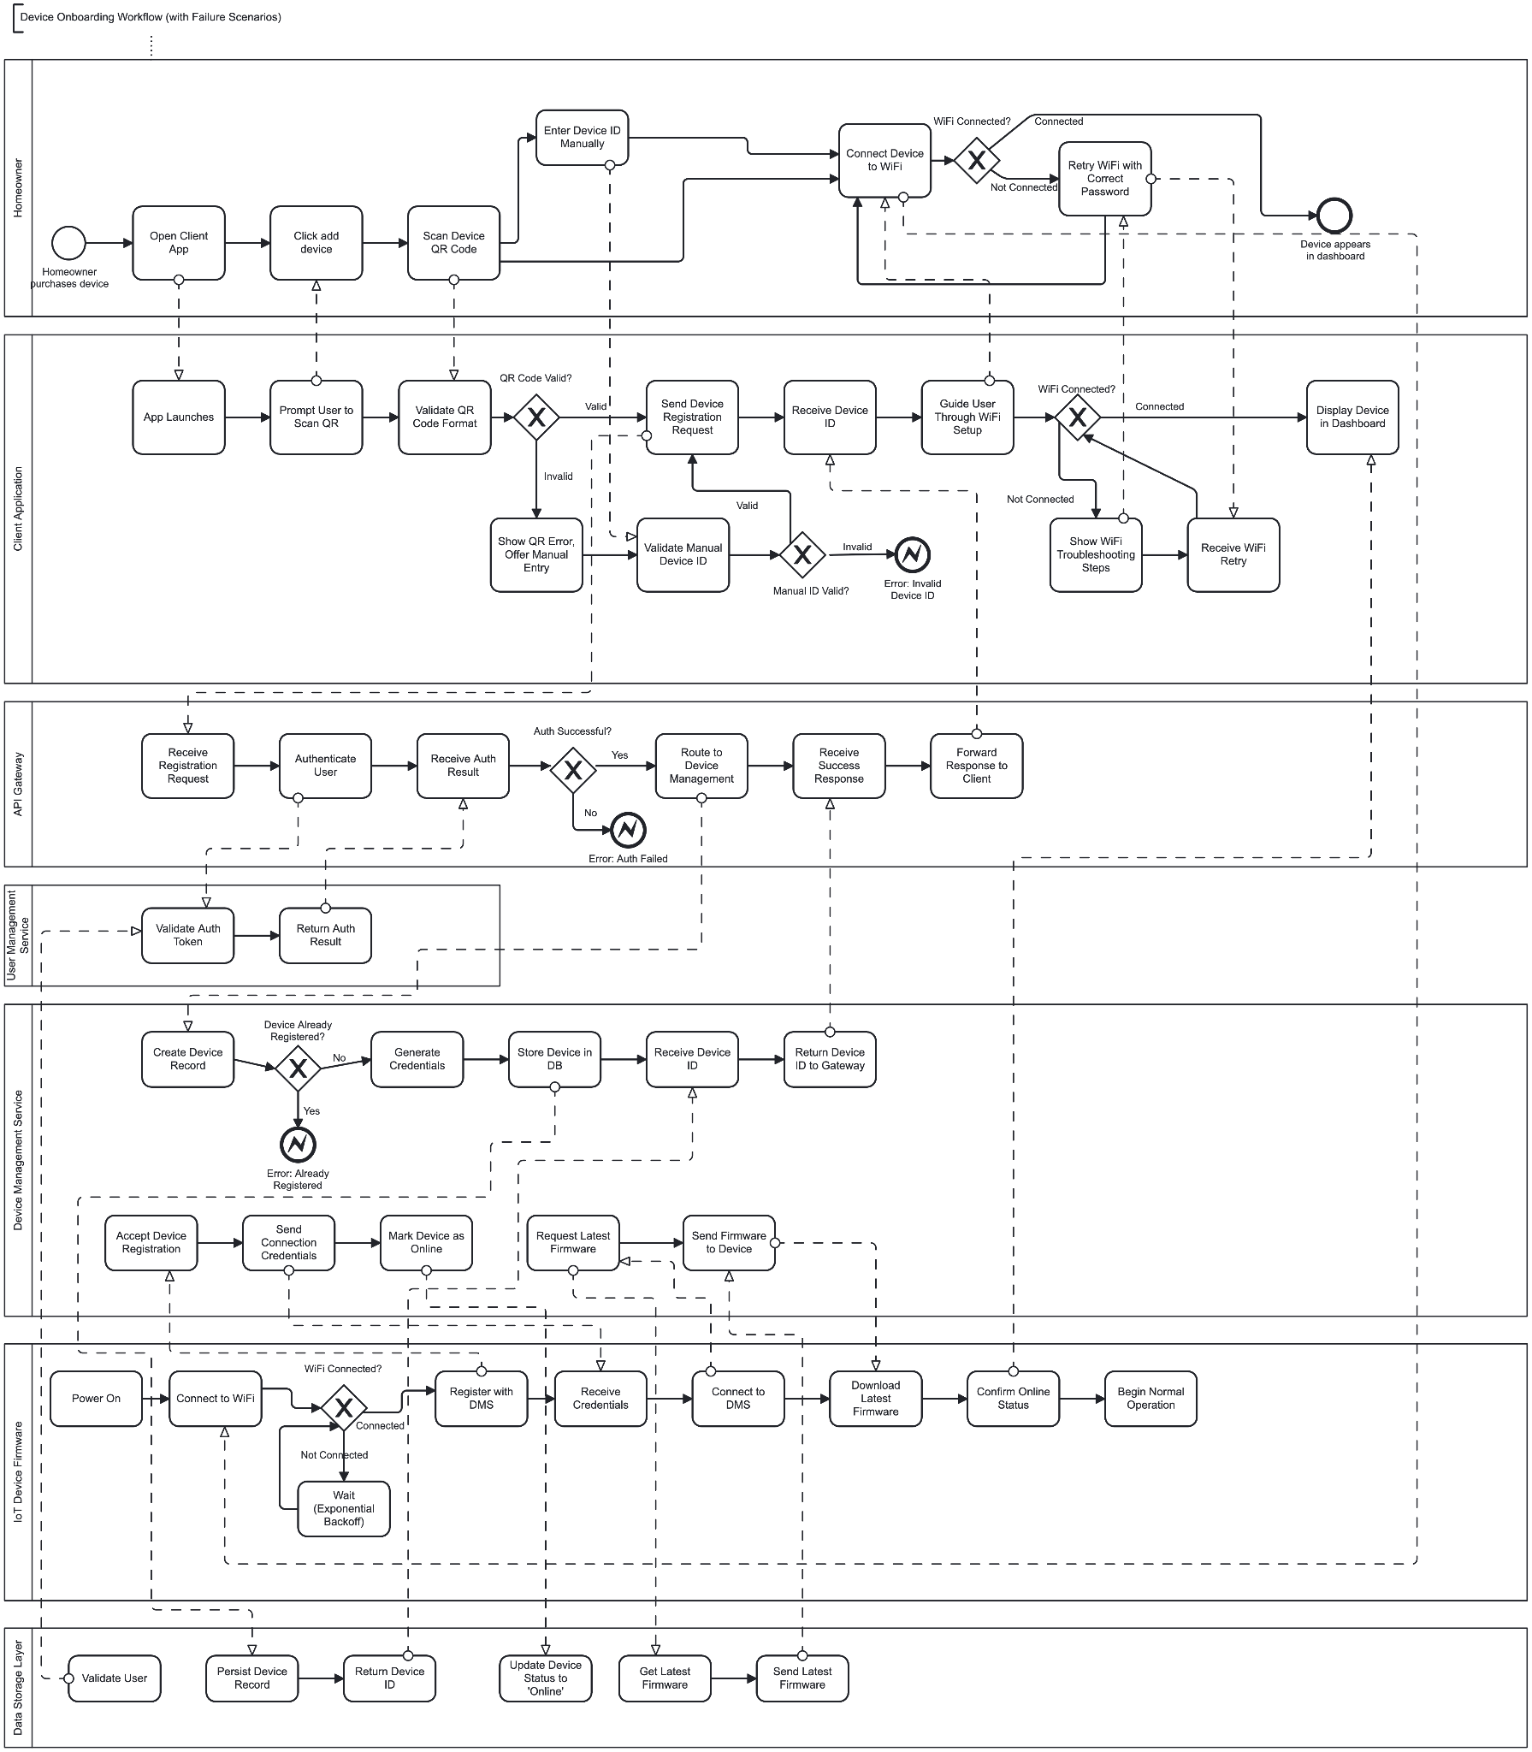
deviceOnboardingWorkflowWithFailures
This workflow describes how a homeowner adds a new IoT device to their SecureNet account. Six participants are involved: the Homeowner, Client Application, API Gateway, User Management Service, Device Management Service, IoT Device Firmware, and Data Storage Layer.

Happy path:
- The homeowner opens the Client App and taps 'Add Device'. The app prompts a QR code scan.
- The app validates the QR code format. If invalid, it offers manual device-ID entry and validates that instead.
- The Client App sends a device-registration request to the API Gateway. The gateway authenticates the user via User Management Service, then forwards to Device Management Service.
- Device Management Service creates a device record (PENDING_REGISTRATION), generates DeviceCredentials, and stores both in the Data Storage Layer.
- Meanwhile, the physical device powers on, connects to WiFi, and calls acceptDeviceRegistration(deviceId, token), completing the handshake.
- Device Management Service transitions the device to ONLINE, returns DeviceCredentials, and the device opens its MQTT connection.
- The device downloads the latest firmware, confirms online status, and begins normal operation.
- The Client App displays the device in the homeowner's dashboard.

Failure scenarios handled
- QR code invalid: App offers manual entry; validation error triggers an intermediate error event.
- Wrong WiFi password: App shows troubleshooting steps; homeowner retries.
- Device already registered: Device Management Service returns DeviceAlreadyRegisteredException; gateway forwards error to client.
- Authentication failure: API Gateway throws AuthenticationException; client shows login prompt.

3.2) Workflow 2 - Motion Detection and Alert
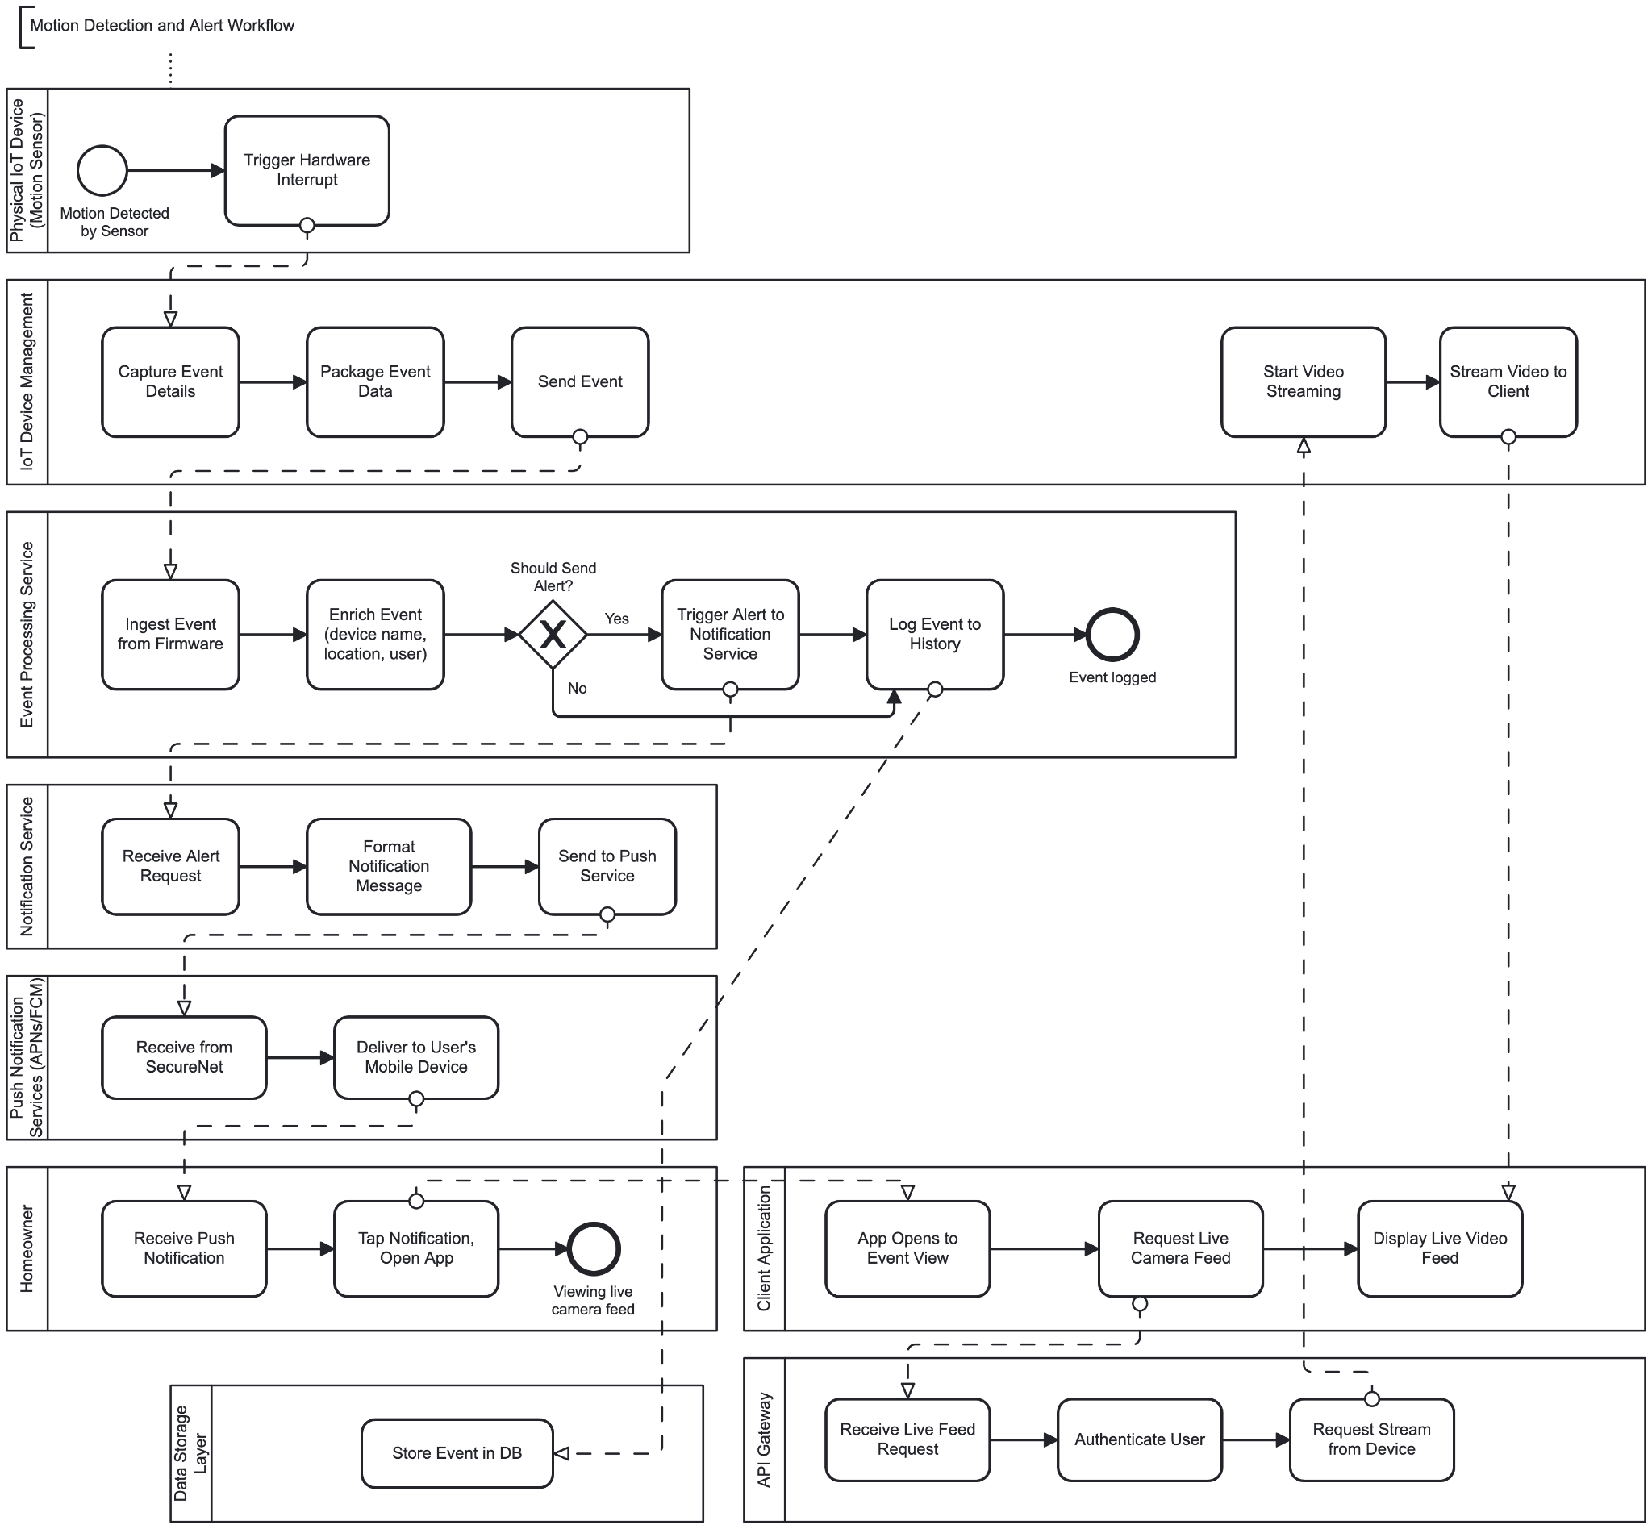
Motion Detection and Alert Workflow
This workflow is initiated entirely by the IoT device (camera or motion sensor) without any homeowner interaction. It demonstrates the event-driven backbone of the SecureNet platform.
Participants: Physical IoT Device, IoT Device Management (firmware), Event Processing Service, Notification Service, Push Services (APNs/FCM), Homeowner, Client Application, API Gateway, and Data Storage Layer.
Happy path:
- Physical IoT Device triggers a hardware interrupt
- IoT Device Management (firmware) captures event details, packages data, then sends
- Event Processing ingests, enriches, evaluates alert criteria, triggers Notification Service, and logs to DB
- Notification Service formats and dispatches through Push Services
- Push Services delivers to the homeowner's device
- Homeowner taps notification -> Client App -> API Gateway -> Device Management -> Video Streaming

3.3) Workflow 3 - Remote Door Lock
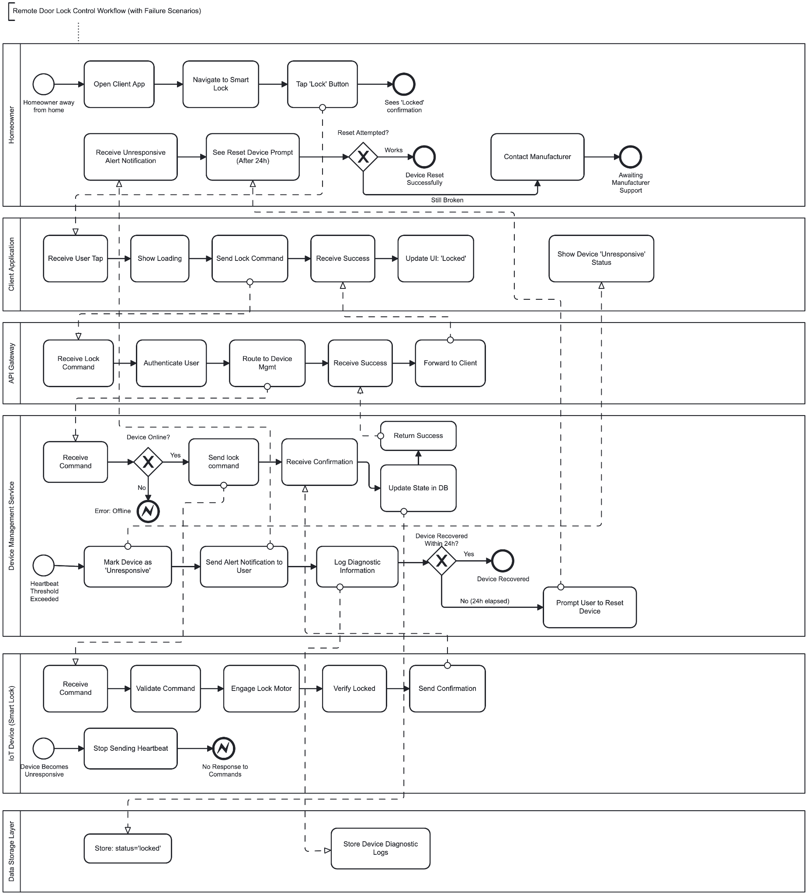
Remote Door Lock Workflow
This workflow is homeowner-initiated. It demonstrates the round-trip command path from a user tap in the mobile app all the way to a physical actuator on a smart lock, and back.
Participants: Homeowner, Client Application, API Gateway, Device Management Service, IoT Device (Smart Lock), and Data Storage Layer.

Happy path:
- The homeowner opens the Client App while away from home and navigates to their smart lock. They tap the 'Lock' button.
- The app sends a lock command to the API Gateway (HTTPS/JSON). The gateway authenticates the token via User Management Service, and routes to Device Management Service.
- Device Management Service verifies the device is ONLINE, then calls sendLockCommand(deviceId), which publishes a LOCK command to the device's dedicated MQTT command topic.
- The IoT Device Firmware's handleCommand(LOCK) engages the lock motor, verifies the locked state, and publishes an acknowledgement back to the MQTT broker.
- Device Management Service receives the ack, calls StorageService.updateDevice() to persist the new lock state, and returns success up the chain.
- The API Gateway forwards the success response to the Client App, which updates the UI to show 'Locked'. The homeowner sees the confirmation.

Failure scenarios handled
- Device offline: Device Management Service throws DeviceOfflineException; Client App shows error message.
- Device unresponsive (heartbeat lost): A separate detection flow runs in Device Management Service: markDeviceUnresponsive() -> NotificationService.sendEventAlert() -> homeowner receives alert. If the device is still unresponsive after 24 hours, the app prompts the homeowner to reset the device.

3.4) Workflow 4 - Video Playback
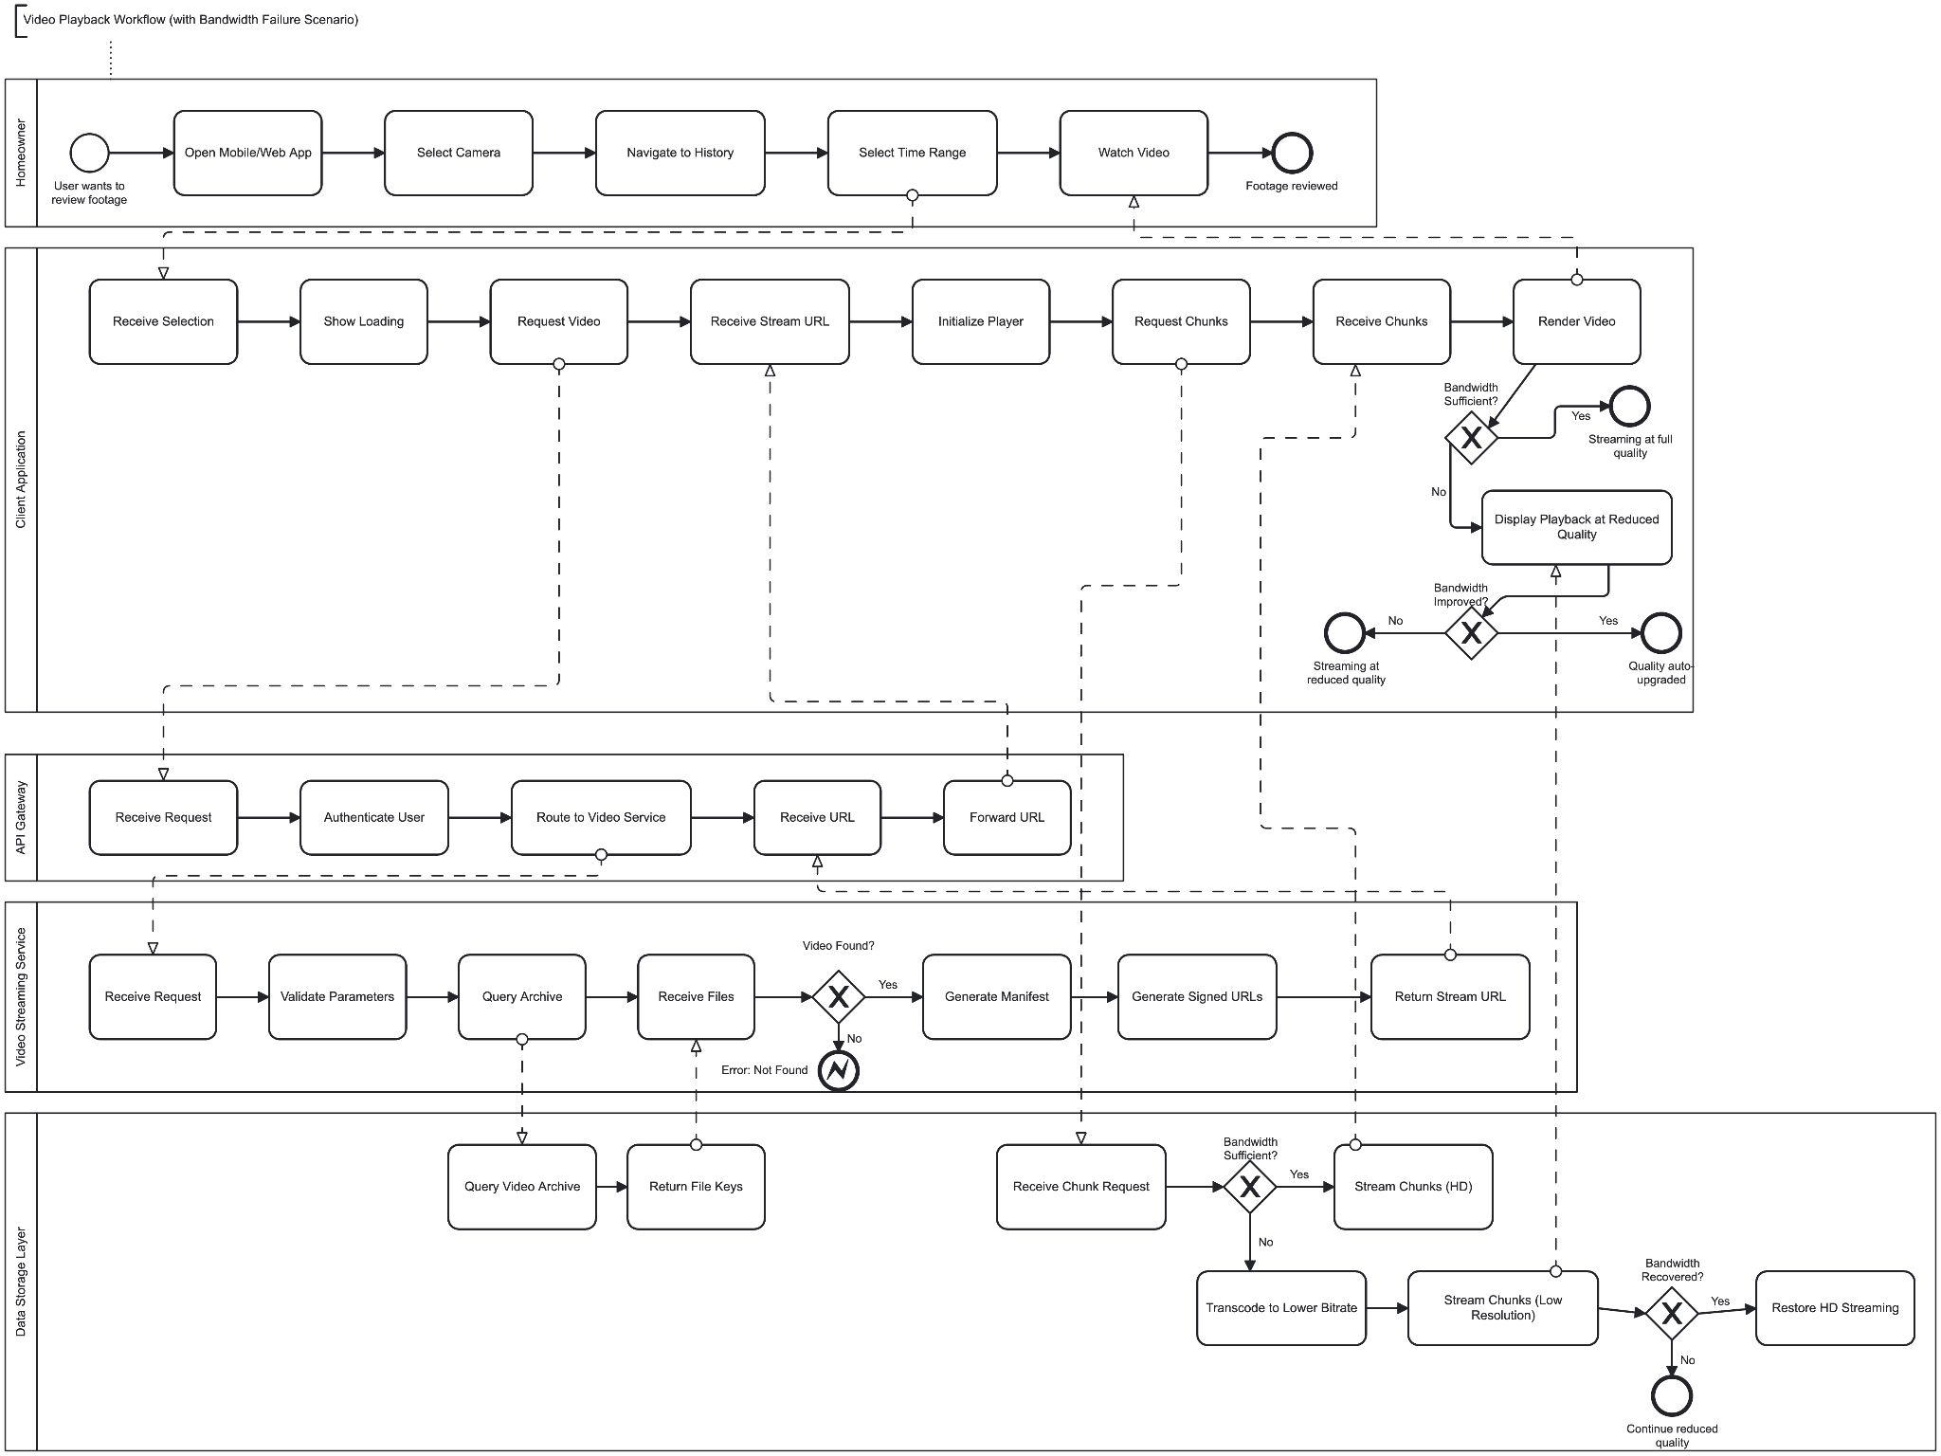
Video Playback Workflow
This workflow describes how a homeowner reviews archived footage. Participants: Homeowner, Client Application, API Gateway, Video Streaming Service, and Data Storage Layer.

Happy path:
● The homeowner opens the app, selects a camera, navigates to History, and picks a time range.
● The Client Application sends a video request to the API Gateway. The gateway authenticates the user and routes the request to the Video Streaming Service.
● Video Streaming Service validates parameters, queries the archive by calling findClips(deviceId, from, to), and receives the file keys from the Data Storage Layer. If no footage exists, an Error: Not Found event is returned and the client shows an empty-state message.
● Video Streaming Service generates a manifest and calls generateSignedPlaybackUrl(clipId, 3600) to produce time-limited HTTPS URLs, then returns the stream URL to the API Gateway, which forwards it to the Client Application.
● The Client Application initializes the player and begins requesting chunks directly from the Data Storage Layer using the signed URL — the API Gateway is not in the video data path. The Data Storage Layer calls loadVideoBytes(storageKey) and streams the chunks back to the client, which renders the video.

Failure scenarios handled:
- No footage found: Video Streaming Service returns an Error: Not Found; the client shows an empty-state message.
- Insufficient bandwidth: The Data Storage Layer detects insufficient bandwidth and calls selectQualityTier(bandwidthKbps) to transcode to a lower bitrate, then streams low-resolution chunks. If bandwidth recovers, HD streaming is restored. If bandwidth does not recover, playback continues at reduced quality.

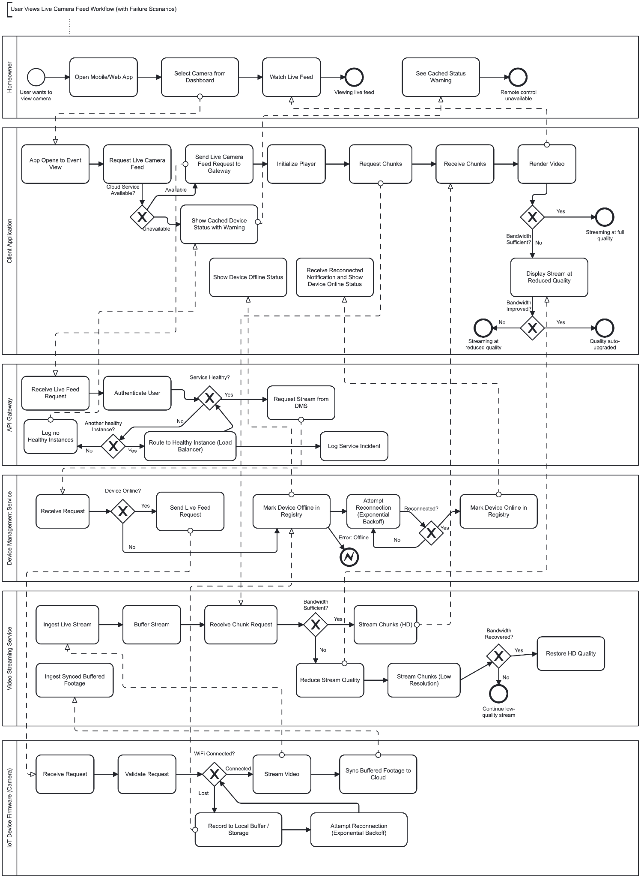
3.5) Workflow 5 - Live Camera Feed

Live Camera Feed Workflow
This workflow covers real-time live streaming.
Participants: Homeowner, Client Application, API Gateway, Device Management Service, Video Streaming Service, and IoT Device Firmware (Camera).

Happy path:
- The homeowner opens the app and selects a camera from the dashboard.
- The Client Application sends a live feed request to the API Gateway. The gateway authenticates the user, checks service health, and routes the request to Device Management Service. Device Management checks that the device is ONLINE, then calls sendStreamStartCommand(deviceId, streamTargetUrl).
- The camera firmware receives the STREAM_START command via MQTT. It validates the request, checks WiFi connectivity, and begins pushing its video stream to the Video Streaming Service, which calls startLiveStream(deviceId, ownerId) and buffers the incoming chunks.
- The Client Application initializes the player and begins calling getNextChunkUrl(sessionId, bandwidthKbps) in a polling loop. The Video Streaming Service calls selectQualityTier(bandwidth) and returns a signed chunk URL. The client renders the video. The homeowner watches the live feed.
Failure scenarios handled:
- WiFi loss (Failure 1): The camera firmware detects WiFi is lost, calls bufferLocally(VIDEO_SEGMENT, bytes), and attempts reconnection with exponential backoff. Device Management marks the device OFFLINE and the Client Application shows the device offline status. When WiFi is restored, the firmware calls syncBufferedData() to deliver buffered footage to the Video Streaming Service, and Device Management marks the device ONLINE. The homeowner receives a reconnected notification.
- Cloud unavailable (Failure 2): The Client Application detects the cloud is unavailable before requesting the stream. It shows cached device status with a warning indicator and remote control is unavailable. The API Gateway logs the incident via logServiceIncident(). If another healthy instance exists, the gateway routes to it via load balancing.
- Insufficient bandwidth (Failure 3): Video Streaming Service detects insufficient bandwidth, calls selectQualityTier(bandwidthKbps), reduces stream quality, and streams lower-resolution chunks. The Client Application displays the stream at reduced quality. When bandwidth improves, quality is automatically upgraded and the client shows ‘Quality auto-upgraded’.

